Applications are now available for the 2021 – 2023 Young Farmers & Ranchers Leadership Group. This is a two year leadership development and training program designed to prepare the next generation of farmers and ranchers with the leadership skills and confidence to represent agriculture at the local, state, and national level. This program focuses on personal growth, public speaking, media training, legislative awareness, issue advocacy and service leadership while learning more about the diversity of Florida’s agriculture industry.
The YF&R Leadership Program will utilize several methods in developing the leadership skills and knowledge of its participants.
- Educational opportunities and experiences for young members to learn more about the history, philosophy, structure, programs and services of the Farm Bureau Federation.
- Leadership training for young members so they can become better prepared to assume the responsibilities of leadership and positively promote agriculture and Farm Bureau.
- Opportunities for young members to actively participate in all Farm Bureau activities at county, state and national levels.
- Personal/professional skill development sessions designed to help participants understand themselves and how to effectively work and communicate with others.
The Young Farmer & Rancher (YF&R) Leadership Group is composed of appointed Florida Farm Bureau Federation members between the ages of 18 and 35 years, representing each of the eight Florida Farm Bureau Field Districts. Appointments are made for a two-year term, during which members participate in a study/travel program of approximately 45 days, conducted in thirteen (13) seminars. Eleven seminars will be held in selected locations throughout Florida, one will be held in Washington DC and one will be held out-of-state for the American Farm Bureau Federation Fusion conference.

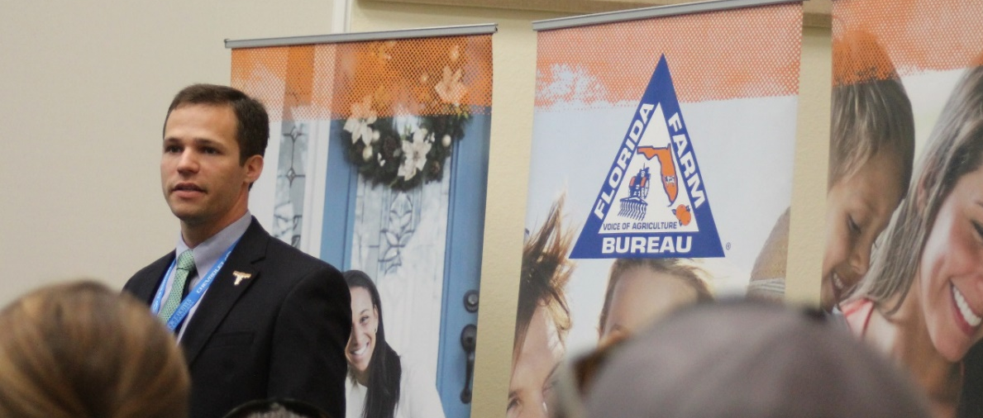
Qualifications
- Participants shall be voting (active) Florida Farm Bureau members, as defined by the Florida Farm Bureau Federation By-Laws Article 5 Section 2.
- FFBF membership in good standing for minimum of one (1) year prior the Young Farmers & Ranchers Leadership Program as of October 1.
- Must be between the ages of 18 and 35 years, and will not turn 36 years prior to October 31, 2023.
- Participants shall not be salaried employees of the Florida Farm Bureau Federation or its affiliates.
See tentative program schedule on the next page for more information. To apply, visit https://www.floridafarmbureau.org/programs/young-farmers-and-ranchers/. Applications must be submitted through Formstack.
Application deadline: Friday, July 16th, 2021 at 11:59pm (EST).
Questions, please contact the program coordinator at Michele.Curts@ffbf.org.
2021 – 2023 Tentative Schedule of Events
Date | Event | Location
Seminar I  November 11th- 13th , 2021 | Orientation | Gainesville, FL
Seminar II  January 2022* | Farm Bureau Days | Tallahassee, FL
Seminar III  March 2022* | AFBF YF&R Conference | TBA
Seminar IV  May 12th – 14th, 2022 | Leadership Training | Gainesville, FL
Seminar V  July 8th – 10th , 2022 | State YF&R Conference | TBA
Seminar VI  August 4th – 6th, 2022 | Leadership Training | Gainesville, FL
Seminar VII  October 26th – 28th, 2022 | FFBF Annual Meeting | Orlando, FL
Seminar VIII  January 2023* | FL Agriculture Farm Tours | TBA
Seminar IX  March 2023* | Farm Bureau Days | Tallahassee, FL
Seminar X  April/May 2023* | Field to the Hill | Washington, DC
Seminar XI  May 2023* | Leadership Training | Gainesville, FL
Seminar XII  July 2023* | State YF&R Conference | TBD
Seminar XIII  October 25th – 27th, 2023 | FFBF Annual Meeting  Program Graduation | Orlando, FL
*Tentative Dates

