COMMUNICATIONS TOOLKIT
Food Check-Out Week is an OUR FOOD LINK event.
FOOD CHECK-OUT WEEK | FEBRUARY 17-21, 2020

Introduction
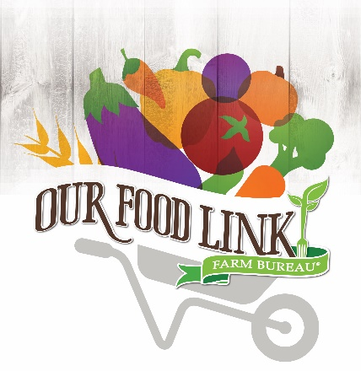
Food Check-Out Week is celebrated the third week in February. It is just one example of the Our Food Link* outreach programs that county Farm Bureau volunteers use to reach consumers to help engage them in today’s agriculture.
We have designed this toolkit to help you plan and implement a Food Check-Out Week activity in your area. For ideas on different events that can be held year-round, we encourage you to review the
Our Food Link Planning Toolkit.
Please contact the Florida Farm Bureau Public Relations
Division at 352.374.1535 for any questions or
assistance in organizing your event.
Thank you for helping to enhance awareness of the bountiful abundance
provided by Florida agriculture.
Happy Planning!

CONTENTS
About Food Check-Out Week 3
Talking Points 4
Media Tips 5
Sample Media Advisory 7
Sample Letter to the Editor 8
Sample Press Release 9
Sample Proclamation 10
Events & Celebration Ideas 11
Social Media 14
Graphics 16

ABOUT FOOD CHECK-OUT WEEK
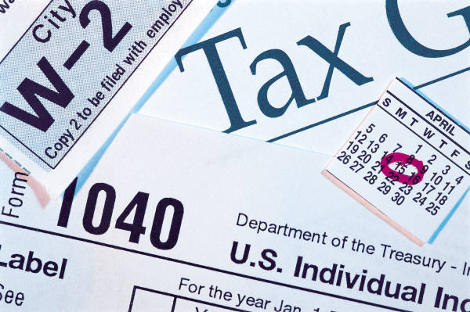
Feb. 17 through 21 is Food Check-Out Week, a time to celebrate the abundance of fresh and nutritious food available to consumers at affordable prices.
The average American household spends less than 10 percent of their disposable income on food. This is the lowest of any country.
According to the U.S. Department of Agriculture, the average family of four will earn enough money to pay for their entire food supply for one year after seven weeks of working. By comparison, it takes 100 days of work to earn enough income to pay your taxes.
Farm Bureau members statewide use this week to highlight Florida agriculture and the healthy and nutritious food that farmers and ranchers provide us throughout the year.
Some community projects that Farm Bureau members have been involved in include mystery shopper events, food sampling booths, celebrity chef cook-offs, Farm-to-Table events, class-room activities, pop-tab collection drives, contributions to Ronald McDonald House Charities, Inc. and aid to local food banks.

TALKING POINTS
- The average American is three generations removed from the farm. Food Check-Out Week is a time to recognize the productivity of farmers and ranchers and help educate more people about where their food comes from.
- Officially celebrated in the third week of February, Food Check-Out Week is traditionally the time that many families have earned enough income to buy their groceries for the year.
- When applied to calendar days, the average American earns enough income to pay for an annual supply of food in just seven weeks. By comparison, the same person must work until mid-April to pay for yearly income taxes. That’s seven weeks for food and more than three months for taxes.
- American consumers spend less than 10 percent of their disposable income (money for spending or saving) for food, compared to 18 percent in 1960. (U.S. Department of Agriculture’s Economic Research Service)
- Based upon the most recent studies, the U.S. Department of Agriculture reports that the “farmer’s share” of the food marketing bill at the grocery store or restaurant is 10.4 cents.
- According to the U.S. Department of Agriculture’s 2014 Consumer Expenditure Survey, 59 percent of domestic food purchases are groceries for home, while 41 percent is spent at a restaurant.
- Technological advances in agriculture have been influential in driving change in the farm sector. Farmers are able to grow more on less land. Total farm output more than doubled between 1948 to 2011.
- A health-boosting diet includes varieties of fruits, vegetables, low-fat or fat-free dairy products, lean meats, beans, eggs and nuts in quantities for daily calorie needs. According to the USDA, all forms of fruits and vegetables count towards a good diet – fresh, frozen, dried and canned.

- Plan balanced meals using the U.S. Department of Agriculture’s MyPlate food guidelines. Visit http://www.choosemyplate.gov/ for more information.
- The agency recommends that half of your plate should consist of fruits and vegetables; half of all grains should be whole grains. USDA researchers also suggest the use of fat-free or low-fat milk.

- Local farmers’ markets often have fresh vegetables, fruits, meats and other items that have been produced in the surrounding area near your home.
- Both crop and animal food production are guided by Best Management Practices – state-of-the-art techniques designed and tested by experts at research universities.
- Energy prices will continue to play a major role in retail prices for food and other items in the U.S. economy. The recent declines in fuel prices will ease the upward pressure on most consumer items.
- Last year Florida Farm Bureau’s Young Farmers and Ranchers have donated more than 20 million pounds of fresh produces and food to assist hungry Americans. This is just one example of Farm Bureau members’ generous contributions to their communities.
- The Florida Farm Bureau Women have distributed more than $200,000 to various charities through the Women’s Fund.

- Support local farmers and ranchers by purchasing the foods they produce.

MEDIA TIPS

The general news media are great targets to help amplify your message for Food Check-Out Week. Reach out to reporters early. Here are just a few tips:
Select a Media Relations Liaison
Designate one person to serve as your media relations liaison. The person will be the main contact for Food Check-Out Week events and will respond to media inquiries.

Identify Your Spokesperson(s)
Identify area farmers and ranchers who can talk about what they do and the impact their enterprises have on the local economy. Identify local leaders who will talk about their support of agriculture and agricultural issues. You can also work with your local IFAS Extension office to provide a speaker on specific topics relating to health and nutrition. A local dietician may also be available to speak.
Contact the Media
Contact your local media to inform them of your Food Check-Out Week event. Tailor and localize the sample news release to increase your chances of coverage. Send the release to electronic and print media reporters and assignment editors in your area. Be sure to follow-up with key contacts to discuss local news and feature angles (i.e. food bank donations or grocery store events) for Food Check-Out Week. Do not expect coverage if you wait until the "eleventh hour."

Have a Hook
What makes your event and activities around Food Check-Out Week unique, exciting, and relevant to the issues news outlets are covering in your area? Reporters and readers want a storyline that helps them understand why something is new and different. You are more likely to get coverage by focusing on the local people involved with your event, (i.e. farmers who donate to a charity, participate in a food display or any issue relevant to your community).

Media Advisory/Press Release
A media advisory is different than a press release. An advisory is sent before an event to the media to urge them to attend. Be sure to include the what, when where, when, why and who of the event. Send your advisory out 1 week before event (earlier depending on your newspaper circulation). Follow-up with a courtesy call one-to-two days prior to your event. A press release includes information on Food Check-Out Week and quotes from your spokesperson. It is intended to provide reporters information to include in a story.
6

Letter to Editor
In preparation for Food Check-Out Week, write a letter to your local newspaper editor in support of the week. Be sure to write a positive editorial about how the event impacts the local economy or community. You want to include any facts in support of your topic. Research in advance the newspaper staff member who covers agricultural, food and local issues.

SAMPLE MEDIA ADVISORY
TIP Be sure to brief your spokesperson on all facts related to your event.
[Date]
[Contact Name and Information]
MEDIA ADVISORY
Local Farmer Invites Public to Harvest Fresh Veggies for Food Bank
Introduction paragraph of event purpose can be one-two lines.
What: Name of event
Who: Farm name/subject name
When: Date of event and time
Where: Address of event location
Why: State the purpose of event in regards to Food Check-Out Week
For more information, contact <NAME at PHONE>
###

SAMPLE LETTER TO THE EDITOR
[Date]
[Contact Name and Information]
Dear Editor:

The foundation of our well-being as a society depends upon the domestic production of food. Our farmers and ranchers provide us with an abundant, nutritious food supply throughout the year.

In recognition of this achievement, members of the ___________County Farm Bureau and _________________ will celebrate Food Check-Out Week from Feb. 17 through Feb. 21. We will <STATE EVENT OR PROJECT.>
We are pleased to share this abundance with our fellow residents.
Thanks to the productivity and efficiency of Florida’s agricultural producers, they continue to maintain a stable bounty of food in our communities. Their dedication and skill levels have overcome a difficult marketplace, weather extremes and plant and animal pests and diseases.
Their effective natural resource management provides crucial environmental benefits to all Floridians. According to state officials, farmers and ranchers conserve 12 billion gallons of water each year by their care.
Farm families achieve these successes despite receiving a steadily smaller portion of the retail grocery dollar. According to new U.S. Department of Agriculture data, in 1973 farmers and ranchers received approximately 30 cents out of every dollar spent on food. By 2018. the share farmers and ranchers received had declined to approximately 10.4 cents. The pattern remains the same for this year. Off-farm costs – processing, packaging, transportation, wholesaling and retailing – account for the majority of the food prices consumers pay.
Most of the recent increases in retail food prices have been the result of higher prices of energy needed to process, haul and refrigerate food.

Our bountiful domestic food supply is the product of skill and dedication. We invite area residents to join us in celebrating the farmers and ranchers who grow healthy and nutritious foods.
The ________________________________ County Farm Bureau urges you to join us in our Food Check-Out Week event(s). We are proud to highlight Florida agriculture and the people who make it successful.
(Signed)

SAMPLE PRESS RELEASE
[Date]
[Contact Name and Information]

Food Check-Out Week Event Highlights Farm Service to the Community

(Town) Members of the ___________________ County Farm Bureau will celebrate Food Check-Out Week on (date) by < INSERT ACTIVITY THAT COUNTY MEMBERS WERE INVOLVED IN>.
A fundamental part of our well-being as a society depends upon the domestic production of food. Our farmers and ranchers provide us with an abundant, nutritious food supply throughout the year. Food Check-Out Week, set for Feb. 17-21, commemorates the value of this achievement for all Floridians.

Local Farm Bureau members have volunteered to lead the event. They represent farm families throughout the area. We invite area residents to join us in this community activity.

County Farm Bureau President (or another volunteer leader) __________________ said, “INSERT QUOTE.”
(County) Farm Bureau is affiliated with the Florida Farm Bureau Federation, the state’s largest general interest agricultural organization, representing more than 146,000 member-families. Florida Farm Bureau serves to enhance farm enterprise and improve rural communities.
###

SAMPLE PROCLAMATION
TIP
Follow-up with a personal phone call to your local media and always thank the media. Politeness goes a long way!
[NAME OF GOVERNMENT AGENCY]
FOOD CHECK-OUT WEEK
February 17-21, 2020
By [TITLE OF OFFICIAL]
A PROCLAMATION
WHEREAS it is important that Americans have access to and consume healthful foods containing adequate vitamins, minerals, fiber and other nutrients; and
WHEREAS achieving better nutrition with fewer resources remains a shared concern of our citizens that can be addressed through consumer education and wise shopping strategies; and
WHEREAS Florida farmers and ranchers are unmatched in their ability to consistently produce an abundance of safe, nutritious and affordable food; and
WHEREAS producers confront significant uncertainties including inclement weather, damaging insects and other challenges, on a daily basis; and
WHEREAS [COUNTY OR STATE] farmers, ranchers and others involved in agriculture, working together in an environmentally sustainable way, help feed people here in [COUNTY/CITY], our state, our nation and in other countries around the world;
NOW, THEREFORE, I, [We] [NAME OF OFFICIAL(S)], [TITLE OF OFFICIAL(S)], do hereby proclaim February 17-21, 2020, as Food Check-Out Week. I [We] call upon all Americans to join me [us] in recognizing and reflecting upon the strength of our diverse agricultural production and in celebrating its achievements with appropriate observances and activities.
IN WITNESS WHEREOF, I have hereunto set my hand this (DAY) of (MONTH), 2020.

TIP
Connect with your local city or county officials to schedule proclamation signing at least two months in advance!

EVENT AND CELEBRATION IDEAS
Looking for some ideas to help connect the farm to city? Here are some "tried-and-true" ideas that have worked well for celebrating Farm-City Week!
Farmer’s Markets
Local farmer’s markets provide a great opportunity to highlight the necessary relationships between farmers and consumers. Set up a booth and make a day of it with nutritional hand-outs, fun kid-friendly games and tasting demos. See our recipe card template at the end of this kit to use for your own favorite recipe!

Food Check-Out Week Breakfast
Host a Food Check-Out Week breakfast for local government and business leaders. Identify a keynote speaker to talk about healthy and nutritious foods and the local impact agriculture has. Plan your menu around local commodities. You may also consider working with other civic groups such as Kiwanis, Lions or Rotary clubs. If you live in a college town, reach out to the Collegiate Farm Bureau chapter or local sorority or fraternity groups.

Grocery Store Display
Work with local grocery stores to set-up educational stations throughout the store in the produce, dairy, meat and bakery sections. Reach out to local farmers to help work at the stations. Shoppers are able to meet local farmers and learn about healthy foods. Check to find out if the grocery store manager will include Food Check-Out Week fact cards in the grocery bags or on the carts.

Cooking Demonstrations
Work with a local grocery store to host a cooking demonstration using local products. Partner with store employees or the local culinary school students to create a recipe. Be sure to use the Food Check-Out Week recipe card as a hand-out.
Fitness Fair
Host a farm or health and nutrition fair. Possible partners you could reach out to include your Extension office, a health clinic, a gym facility and area farmers and ranchers. Consider working with the American Heart Association (Wear Red Day is Feb. 1) to help promote eating healthy.

Legislative Farm Tour
Invite one or more state legislators to visit local farms and ranches to help bring awareness to the positive impact of agriculture on the local economy. You could have a public signing of the proclamation on the farm to further hook media. Include a bagged lunch with agriculture facts.

Day on the Farm
Host a classroom field trip to a local farm or ranch or to a university’s agricultural research farm. This is a great opportunity for children to learn about where their food comes from. You can also invite a farmer or rancher to speak to a local classroom.

Ronald McDonald Promotion
Work with the local McDonald’s fast-food chain (or any restaurant) and promote the week with a healthy menu tie-in. Proceeds for selected menu items could be donated to the local Ronald McDonald House.
Host a Celebrity Cook-Off
Host a celebrity cook-off with a local media celebrity, farmer and local chef. Use a local personality to MC the event and use ticket sale proceeds to fund a local charity or Ronald McDonald House.

Farm to Table
Work with a local farmer to host a farm-to table meal event. Promote the fact that proceeds will support a local charity, food bank or scholarships for the local FFA or 4-H chapter.
School Lunches
Work with local schools and the school lunch program to have agricultural displays set up to help explain the connection between farm and mealtime. Host a healthy menu contest. Have students can create their own menu by using locally-sourced products. The winning menu can be featured on the monthly school menu.

Library Display
Work with your local library to feature a Food Check-Out Week display. Choose books on food and farms to encourage children to learn more about agriculture and how it affects their lives. At the same time, show books about eating healthy to promote fresh fruit and vegetables.

Food Drive
Work with your local food pantry or charitable organization to organize a food drive. Many farms share their unused harvest with local food banks so that underprivileged community members can enjoy nutritious and wholesome foods.

Media Luncheon
Host a media luncheon and treat them like stars. Feed them and give them their own farm tour. Increasing their understanding may lead to better coverage.

Restaurant Night
Go to a restaurant that purchases from local farms. Include Farm-City Week table tents displaying facts related to agriculture and nutrition on the tables. Offer to pay for one guest’s meal “courtesy of your County Farm Bureau,” or sponsor a Kids Eat Free night courtesy of “your County Farm Bureau.” This allows you to reach people that wouldn’t normally come to Farm Bureau events.

School Garden
Start a school garden at an area school that doesn’t have one. Start teaching kids about where their food comes from and the importance of agriculture.
Leverage Resources
As you plan your Food Check-Out Week, be sure to tap into your community. Many school clubs are eager to help out with an event and can use the time for necessary community service hours required for graduation. FFA and 4-H students are great resources to help with agricultural events.
TIP
Leverage February Tie-Ins with Event:
-National Canned Food Month
-National Hot Breakfast Month
-National Snack Food Month
-Berry Fresh in the Sunshine State Month
-National Dental Month
-Return Shopping Carts to the Supermarket Month
-Bake for Family Fun Month
-Great American Pies Month
-National Grapefruit Month
-American Heart Month
SOCIAL MEDIA
Social media is essential for raising awareness about Food Check-Out Week and sharing your event. Be sure to use the hashtag #FoodCheckOutWeek with all of your posts. We’ve created some sample posts that you can use on various social media channels. Feel free to customize posts to best fit your event.

Facebook

- Happy Food Check-Out Week! We are celebrating our farmers and ranchers who bring us a healthy bountiful food supply. We’ll keep you posted on upcoming events!
- DYK the average American household spends less than 10% of their disposable income on food? This is the lowest of any country.
- DYK the average family will earn enough money to pay for their entire food supply for one year in seven weeks? It takes 100 days to earn enough income to pay your taxes.
- Looking for Food Check-Out Week resources? Find them at floridafarmbureau.org/FCOW
Special Event Example:
- Celebrate Food Check-Out Week with us tomorrow night at (Insert Location), (Insert Event name) at (time), Call (insert phone number) for details.
- Create a Facebook Event with details for any events open to the public. Maybe offer two tickets to a lucky winner who shares the event on their own page.

Twitter

- #FoodCheckOutWeek celebrates our nation’s healthy and nutritious food supply!
- DYK the average American spends less than 10 percent of disposable income on food? #FoodCheckOutWeek
- Happy #FoodCheckOutWeek! We are so thankful for healthy and nutritious foods.
- #FoodCheckOutWeek is Feb.17-21. Check out our Facebook page for a full schedule of activities!
- #FoodCheckOutWeek Celebrating our farmers & ranchers who grow affordable food.
Special Event Examples:
- #FoodCheckOutWeek Stop by (Local Grocery) to meet your local farmers
- Join us at (venue) to celebrate #FoodCheckOutWeek. Visit with local health officials and Extension Agents about eating healthy this New Year.
- #FoodCheckOutWeek Local charity benefits from food donations from our farmers and ranchers.
Special Recognition Examples:
- Thank You @FarmerSally for partnering with Farm-to-School to bring fresh food to our students! #FoodCheckOutWeek
- Thank You, @CountyCommisioner________ for partnering with the community to allow farmers to continue producing quality goods! #FoodCheckOutWeek
- Thank You @CommunityLeader for your continued support of agriculture #FoodCheckOutWeek
- Thank You [local grocery store] for carrying local products grown right here in ________ County! #FoodCheckOutWeek

Instagram
- Create a series of topics around your Food Check-Out Week and post a new graphic topic each day (i.e., healthy eating habits, produce grown in county, economic impact of local agriculture.
- Post inspirational quotes related to agriculture or eating healthy
- Show pictures of an event set-up
- Promote speakers for an event with photo.

Pinterest
- Make a Food Check-Out Week Board containing favorite recipes using Florida commodities grown in your county.
- Pin infographics, etc. that show food costs and healthy eating habits. We have included sample infographics within this toolkit.
- Pin your table settings, centerpieces and other original décor.
- Pin other material that would be of interest to members of your community, such as how to build an herb garden or other how-tos.
- Cross-promote your board on other social media pages!
GRAPHICS
We have created a series of infographics that you can use on your social media channels. We encourage county Farm Bureaus and volunteers to use these graphics as provided. You can right click on any of the graphics below and “Save as Picture.” We have also included an Our Food Link logo for your use. For assistance in graphic design for your event, please contact:
Farm Bureau Public Relations Division
Rachael Smith
Rachael.Smith@ffbf.org
352.374.1521

Our Food Link Logo

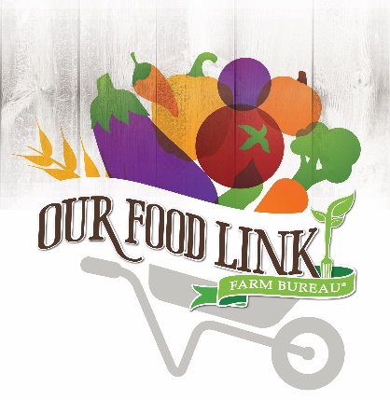

Celebrate #FoodCheckOutWeek is Feb. 17-21!
TIP
Be sure to use #FoodCheckOutWeek on all your social media posts!

Sample Infographics

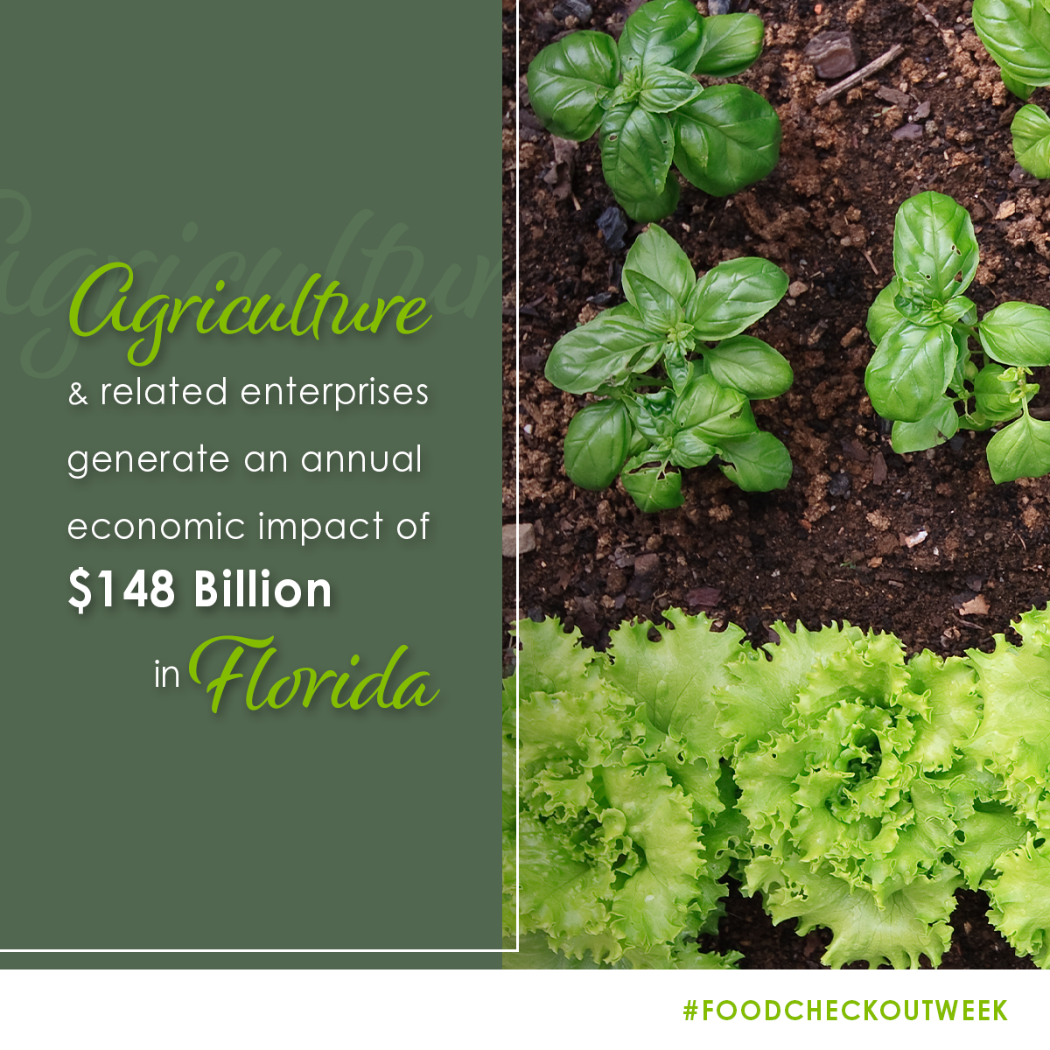
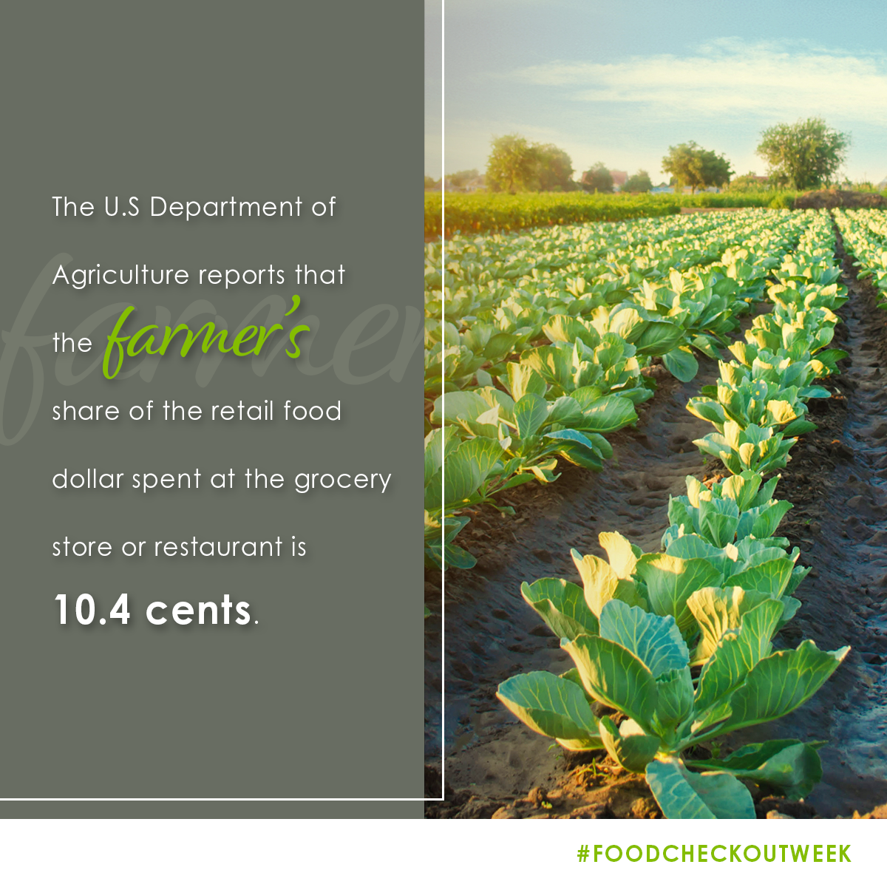
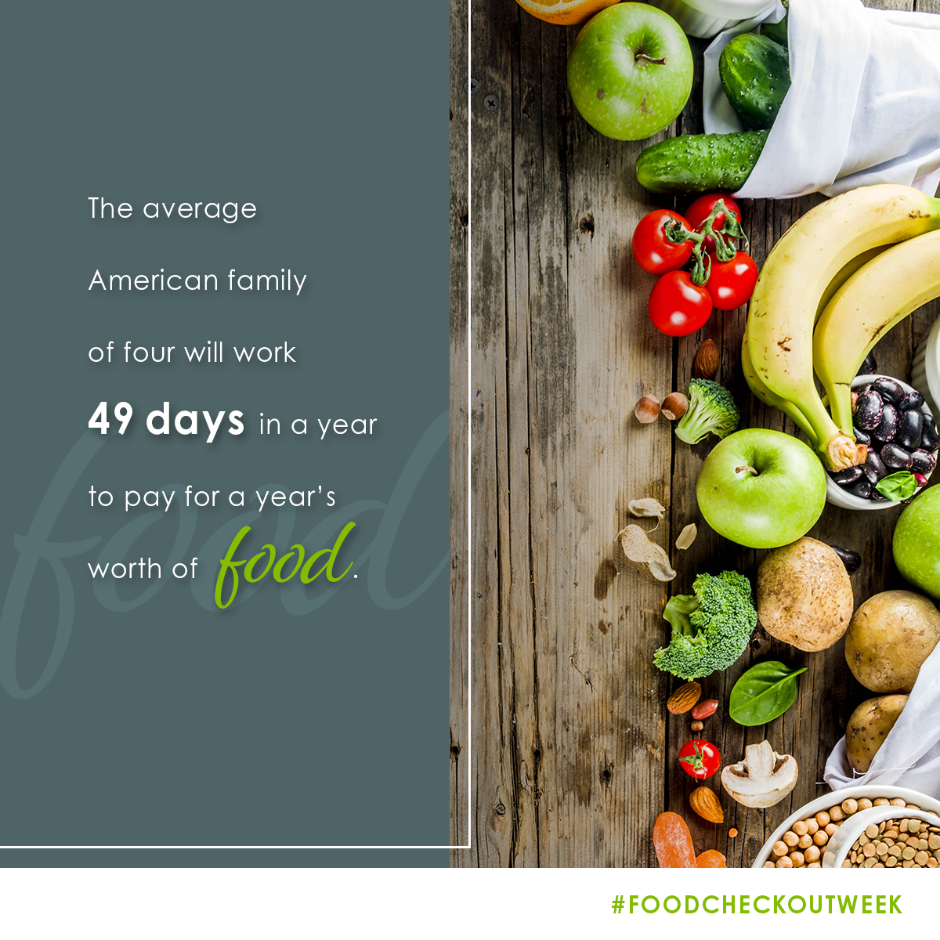

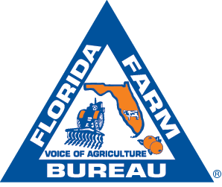
FOOD CHECK-OUT WEEK | FEBRUARY 17-21, 2020

