A Toolkit for Volunteers
Communications Toolkit
Introduction
Nov. 20–27, 2019 is National Farm-City Week, a time to recognize and celebrate the importance of relationships between farmers, consumers, community leaders and everyone in between who contributes to our safe, abundant food supply.
Farm-City Week activities, introduced in 1955, involve educational programming to build interdependence between rural and urban citizens.
Farm-City Week is celebrated by agricultural organizations and other community groups across the country. It’s traditionally celebrated the week before Thanksgiving.
In Florida, county Farm Bureaus often partner with schools and community groups to host award banquets, industry panels, farm tours, essay and poster contests, hands-on agricultural activities for students, food drives, farmers markets, proclamation events, community dinners and much more.
Florida Farm Bureau Federation has developed this communications toolkit to help county Farm Bureaus and other organizations promote Farm-City Week and its events. This toolkit is only a guide. We encourage you to personalize your own message and use local statistics and quotes from agriculturists in your area.
Farm-City week placemats (pictured below) can be ordered using the Member Services Order Form through your county Farm Bureau.
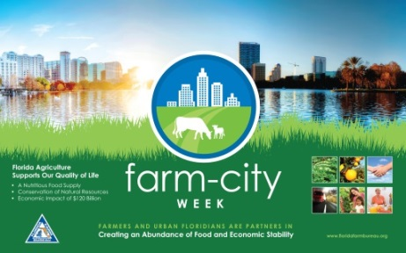
Here’s how you can connect with us:
Public Relations
352.374.1535

This toolkit contains:
Media tips ………………………..……………………………………………………………............…,…. 4

Sample Press Release…………………………………………………………………..…..……..……….. 5

Suggested Social Media Posts and Graphics…………….………………………….……….………... 6

Sample Radio Spot …………………………………………………………………………………...……. 14

Sample Letter to Editor…………………………………………………………………………………….. 15

Sample Proclamation………………………………………………………………….……………..……. 14

Event and Celebration Ideas…………………………………………………………………………….. 18

Media Tips

Select a Media Spokesperson

Designate one person to serve as your media spokesperson. This volunteer will be the main contact for Farm-City Week events and will respond to media inquiries.

Identify Your Spokesperson(s)
Identify area farmers and ranchers who can talk about what they do and the impact their enterprises have on the local economy. Identify local leaders who will talk about their support of agriculture and agricultural issues.
Be sure to brief the spokesperson on the overall message for Farm-City Week. Supply him/her with the speech template that has been created by Florida Farm Bureau and any background material on Farm-City Week.
Contact the News Media

Contact your local news media to inform them of the Farm-City Week event. Tailor and localize the sample news release to increase your chances of coverage. Send the release to electronic and print media reporters and assignment editors in your area. Be sure to follow-up with key contacts to discuss local news and feature angles (i.e. food bank donations or public farm tours) for Farm-City Week. Do not expect coverage if you wait until the "eleventh hour."
Environmental Angle
Invite the media to attend any activities in which farmers and ranchers will be recognized by those outside the profession. A county or city official may recognize local farmers and ranchers for their natural resource conservation with a This Farm CARES award. For agriculture to thrive, both rural and urban areas must commit to protecting our natural resources and diverse ecosystems. A Farm-City Week event is an excellent venue to show the public how farmers are the first stewards of natural resources.

**To personalize your message, please refer to the USDA Census of Agriculture for detailed information about your county on farm land size and market crop value: https://www.nass.usda.gov/Publications/AgCensus/2017/index.php#full_report or
Refer to the UF|IFAS Extension Economic Contribution Reports by County: https://ifas.ufl.edu/extension-economic-contribution-reports/
Sample Press Release
[County Farm Bureau] to Sponsor Farm-City Week Event on [Date]

City, Fla.—Farm-City Week will be celebrated this year from Nov. 20 through Nov. 27. It is a week to express appreciation for the beneficial partnerships between rural and urban communities.
Farmers and ranchers rely on essential partnerships with urban communities to supply, sell and deliver finished products across the country and around the world. Consumer purchases, in turn, make sustainable farm enterprise possible.
Foods, fibers and renewable fuels are available to us because of the daily relationships among farmers and ranchers, processors, brokers, truckers, shippers, advertisers, wholesalers and retailers. The collective efforts by these members of our society provide a wholesome diet for everyone.
In addition, farms and ranches conserve freshwater resources, wildlife habitat and greenspace.
___________________ County Farm Bureau will sponsor (activity) to recognize the contributions of Farm-City relationships to Florida’s quality of life.
Here in ___________County, agricultural businesses include: (list types of agriculture in county, jobs supported and the economic impact of agriculture).
For more information about Farm-City Week activities in our local community, please contact _____________________at the ________________County Farm Bureau.
(County) Farm Bureau is affiliated with the Florida Farm Bureau Federation, the state’s largest general interest agricultural organization, representing more than 146,000 member-families. Florida Farm Bureau serves to enhance farm enterprise and improve rural communities.
###

** Please refer to the USDA Census of Agriculture for detailed information about your county on farm land size and market crop value: https://www.nass.usda.gov/Publications/AgCensus/2017/index.php#full_report
Please refer to the UF|IFAS Extension Economic Contribution Reports by County: https://ifas.ufl.edu/extension-economic-contribution-reports/
Social Media
Please consider our suggestions below. They are ONLY suggestions and you are free to make them your own. Use social media to promote the programs and events specific to your county.

Only use images from this document for the RECOMMENDED platform (i.e. don’t use graphics from our “Facebook” section for an Instagram post). Images are sized differently according to the platform, so Facebook images may only fit correctly on Facebook.

Facebook:
Suggested Facebook status updates:
- It’s time to celebrate the contributions from both rural and urban areas that make our food supply safe and plentiful: It’s Farm-City Week!
- Happy Farm-City Week! We’re celebrating farmers, consumers, shippers, packers, scientists and everyone in between who makes an abundant food supply possible! We’ll keep you posted about our upcoming events.
- Farmers + Consumers = Strong Communities! Happy Farm-City Week! (insert impact of ag stat for your county)!
- From Farm to City there are countless contributors along the food supply chain. Let’s celebrate them all! Farm-City Week is Nov. 20-27.
Special Event Example:
Celebrate Farm-City Week with us tomorrow night at (Insert Event Name), (Insert Location) at (Insert Time). Call (Insert Phone Number) for details.
*Create a Facebook Event with details for any events open to the public. Maybe offer two tickets (or other prizes) to a lucky winner who shares the event on their own page to help get the word out.

Suggested Graphics: [Right click on image to save]
Cover Photos:
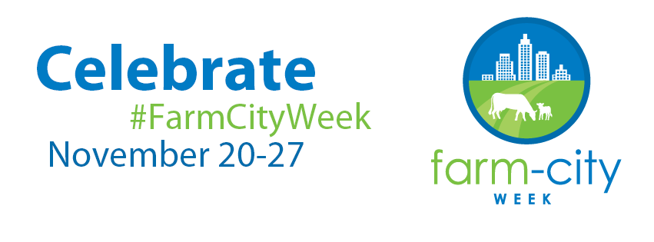
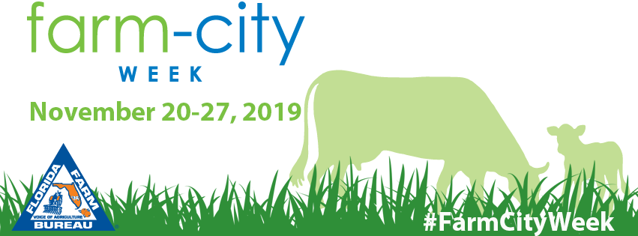

Facebook Feed Post:
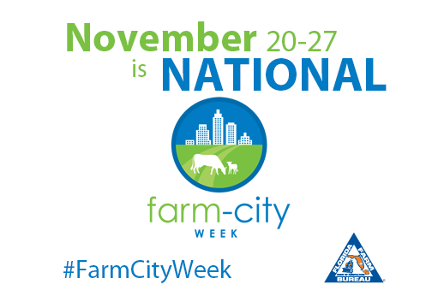
Twitter
Suggested Tweets:
- #FarmCityWeek celebrates the city and rural folks who come together to provide a healthy, abundant food supply!
- Thank you farmers, distributors, retailers and consumers for making the American food supply possible! #FarmCityWeek
- Happy #FarmCityWeek! We are celebrating partnerships between farmers, elected officials, shippers, retailers, scientists, consumers and everyone in between!
- #FarmCityWeek is Nov. 20-27. Check out our Facebook page for a full schedule of activities!
- #FarmCityWeek celebrates strong communities!
Special Event Examples:
- Farm Tours start (Day) at (Location). Sign up through our Facebook page or call (Name) at (Phone Number) #FarmCityWeek
- Join us TONIGHT at (restaurant/venue) to celebrate #FarmCityWeek. Food, prizes and special awards for outstanding community leaders!
- Special Recognition Examples:
- Thank You @(Tag Guest) for partnering with (Insert Program/Organization) to (Insert what the goal/result was)! #FarmCityWeek
- Thank You, @(Tag County Commisioner) for partnering with the community to allow our farmers to continue cultivating great products! #FarmCityWeek
- Thank You @(Tag Community Leader) for your continued support of agriculture #FarmCityWeek
- Thank You (Insert local grocery store) for carrying local products grown right here in (Insert County)! #FarmCityWeek

Suggested Graphics: [Right click on image to save]
Twitter Page Header:

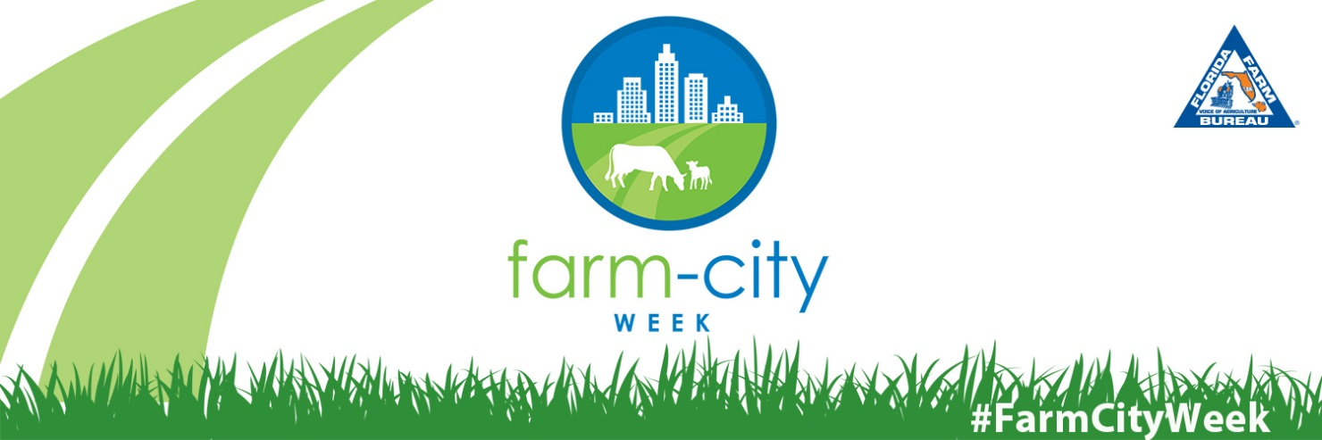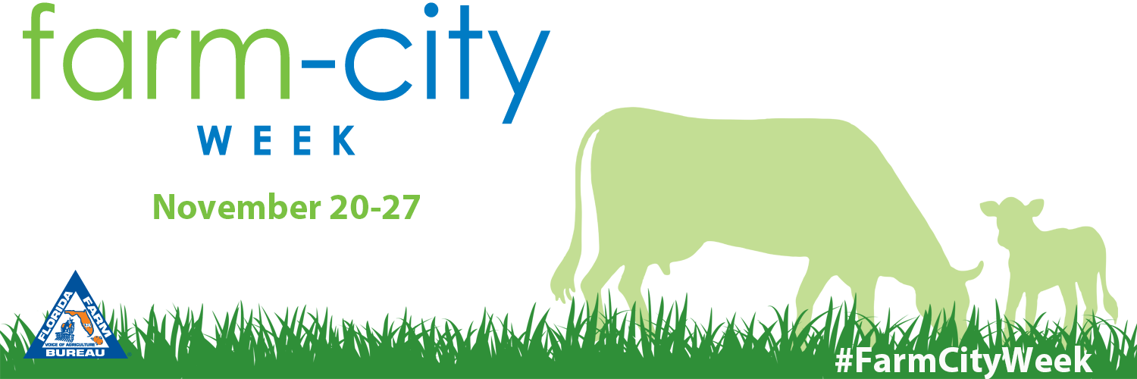

Twitter Post: [Right click on image to save]
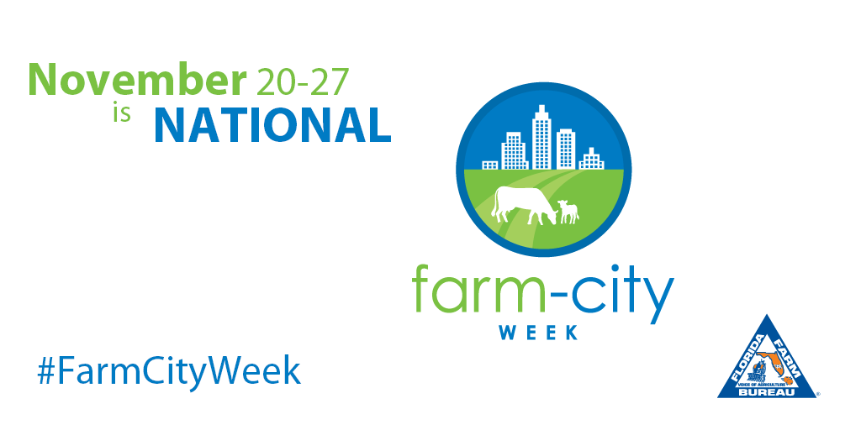

Instagram:
Suggested Graphics: [Right click on image to save]
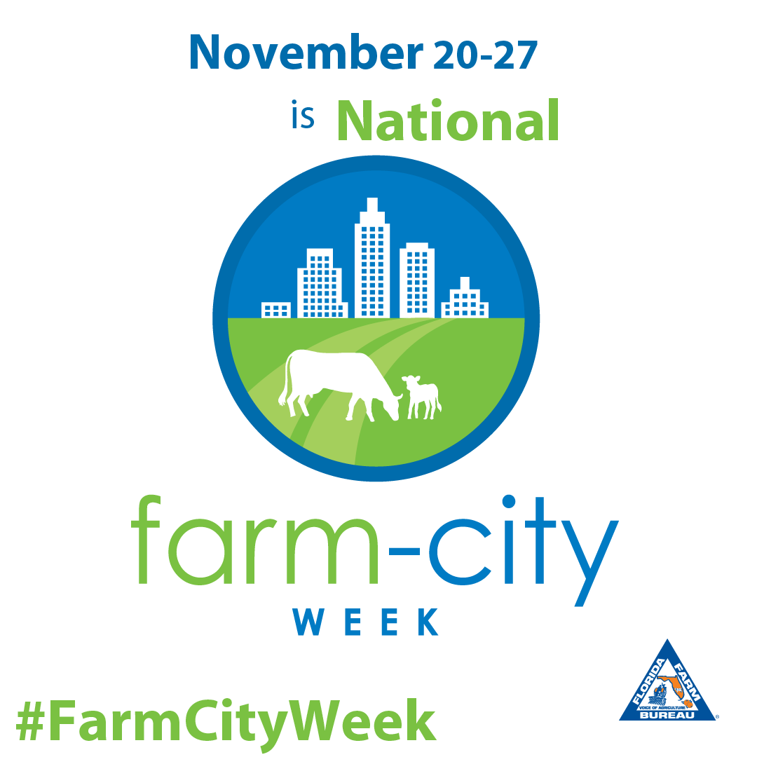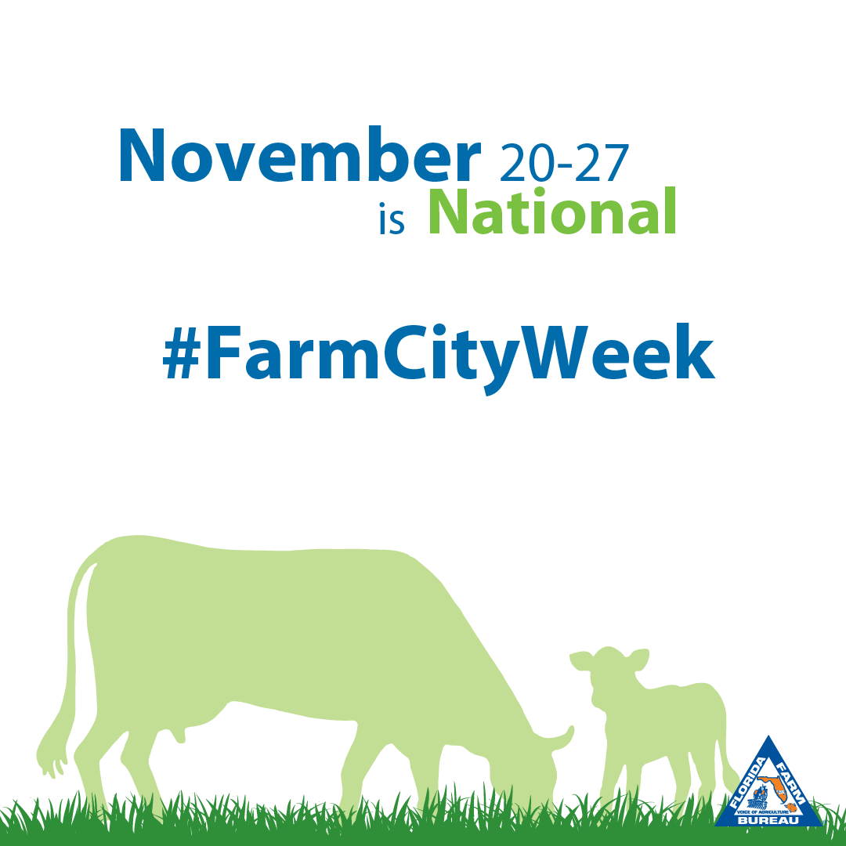
Suggested Instagram Captions:
- #FarmCityWeek celebrates all contributors to the food supply chain working to bring us a nutritious, abundant food supply. Thank you farmers, shippers, retailers and consumers!
- Thank you farmers, distributors, retailers, scientists and consumers for making the American food supply possible! #FarmCityWeek
- Happy #FarmCityWeek! We are celebrating partnerships between farmers, elected officials, shippers, retailers, consumers and everyone in between!
- #FarmCityWeek celebrates strong communities!
Additional Suggestions: Take a photo of your venue or venue sign and caption it with details of the event, including time, location, registration requirements and who to contact with questions.

Pinterest:
Suggestions:
- Make a Farm-City Week Board containing favorite recipes highlighting Florida commodities grown in your county.
- Pin infographics, etc. that show connections between rural and urban communities.
- Pin your table settings, centerpieces and other original décor.
- Pin other material that would be of interest to members of your community, such as how to build an herb garden, or other how-tos.
- Let people know about the board on your other social media pages such as Facebook and Twitter and provide the link to your Pinterest Page!
*Check out Florida Farm Bureau Federation’s “Farm-City Week” Pinterest board for examples* https://www.pinterest.com/FlaFarmBureau/farm-city-week/
Design a Postcard or Flyer:
Here is a postcard one county Farm Bureau made to invite people to their event!
Front: Back:
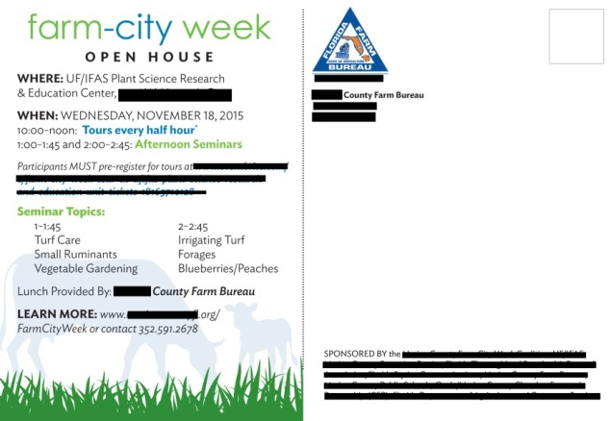
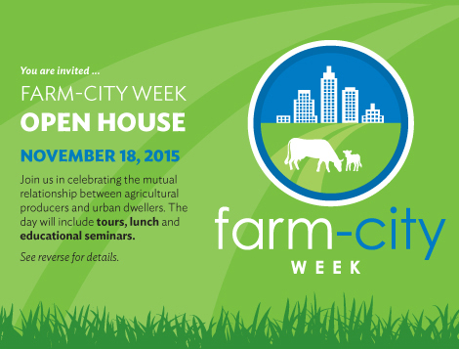

NOVEMBER 24, 2019

Sample Farm-City Week Radio PSA-45 Sec. Spot

Hello, I am ______(your name)_______ of ________(county farm bureau/organization)________. I invite you to join us in celebrating the mutual partnerships between farm producers and urban residents during Farm-City Week, Nov. 20 to Nov. 27.
Farmers and ranchers work hard to provide a nutritious, abundant food supply here in ____________ County and around the world. They are true stewards of the land—maintaining greenspace, wildlife habitat and freshwater recharge areas.
Consumers help sustain farms by purchasing the superior quality foods, fibers and renewable fuels we produce. Businesses in urban areas supply, sell and deliver finished agricultural products to those who need them.
We invite you to join ______(County Farm Bureau/organization)____ in celebrating Farm-City Week, Nov. 20 through 27.
Plan now to attend ________(Event, Date, Location, and Time)_______.
Learn more about Farm-City Week events by following (organization name) on (social media channel) or by visiting FloridaFarmBureau.org (or insert your County website address).

Sample Letter to the Editor
Thanksgiving season is a time when many Americans gather with their families and reflect upon many blessings. One of those blessings is a nutritious and diverse food supply produced by our farmers and ranchers.
We also benefit from other agricultural products that provide clothing, housing, medicines, fuel and other products we use on a daily basis.
These basic necessities are available to us because of a broad partnership of farmers, ranchers, processors, brokers, truckers, shippers, scientists, wholesalers and retailers. Our collaborative partnerships help maintain our standard of living.
In appreciation of our farm-city partnerships, the President of the United States annually proclaims the week leading up to Thanksgiving Day as National Farm-City Week.
Agriculture employs more than two million individuals and annually contributes $127 billion to Florida’s economy.
_______________________ County produces ($number ) agricultural products annually. (More County agricultural stats here. Get them at https://www.nass.usda.gov/Publications/AgCensus/2017/index.php#full_report and https://ifas.ufl.edu/extension-economic-contribution-reports/)
We encourage our fellow citizens to pause for a moment this holiday season and consider the many diverse and healthy foods available to us.
Neither the farm nor the city can exist in isolation. Our interdependence creates jobs, markets and relationships that build our economy and support our collective security.
As we celebrate Thanksgiving, let us remember the farm-city relationships that have allowed us to create an outstanding quality of life for all Floridians.
Please join us in celebrating Farm-City Week, Nov. 20-27, as we give thanks for all that we enjoy.

**We encourage each community to customize this sample so that it fits your respective county. Providing local information and statistics relevant to your community is more likely to be picked up by your local media.

Sample Farm-City Week Proclamation

Florida farmers and ranchers help feed the world by producing a bounty of nutritious foods. To do this, they rely on essential partnerships with urban and suburban communities to supply, sell and deliver finished products to consumers across Florida and around the globe.

Rural and urban communities working together have built our nation’s rich agricultural resources so that they contribute to the health and well-being of our country and the strength of our economy.

During National Farm-City Week, we recognize the importance of this cooperative network. Agriculture and related enterprises employ more than 2 million workers, including farmers and ranchers, shippers, processors, marketers, retailers, inspectors and others who contribute an annual impact of $127 billion to Florida’s economy.

As they perform their daily work, farmers and ranchers preserve freshwater recharge areas, wildlife habitat and greenspace. Consumers help farm families maintain their superior natural resource conservation practices by purchasing Florida’s agricultural products.

Farm-City Week activities celebrate the mutually beneficial relationships that support the quality of life we all enjoy. This week, as we gather with family and friends around the Thanksgiving table, we count these relationships among our many blessings.

We commend the many Floridians whose hard work and ingenuity provide us with food abundance and reflect the true spirit of our state and nation.

Now, therefore, I (We), ____________________________, [title(s)]________________, by virtue of the authority vested in me (us), do hereby proclaim November 20-27, 2019 as Farm-City Week.

I (We) call upon all citizens to acknowledge and celebrate the achievements of all those who, working together, produce and supply our community, our nation and the world with an abundance of agricultural products.

Signed:

Event and Celebration Ideas
Looking for some ideas to help connect the farm to city? Here are some "tried-and-true" ideas that have worked well for celebrating Farm-City Week!

Farmers Markets
Local farmers markets provide a great opportunity to highlight the necessary relationships between farmers and city folk. Set up a booth and make a day of it with hand-outs, fun kid-friendly games and tasting demos.

Farm-City Week Breakfast
Host a Farm-City Week breakfast for local government and business leaders. Identify a keynote speaker to talk about the beneficial rural and urban partnerships in agriculture. Plan your menu around local commodities.

Fair
Host a farm or health and nutrition fair with examples of new Ag uses, Ag technology exhibits, food stands, live animals or entertainment. Work with your local Extension office to help show how scientific research and development support our food supply.

Pizza Commodity Party
Organize a “pizza commodity party” on a farm or in a classroom. Explain how ingredients from kids’ favorite food comes from farms and ranches and how each is processed and delivered to the grocery store or restaurant, emphasizing the relationships that make our abundant food supply possible.

Legislative Farm Tour
Invite one or more state legislators to visit local farms and ranches to help bring awareness of the impact of agriculture to the local economy.

Day on the Farm
Host a classroom field trip to a local farm or ranch or to a university’s agricultural research farm. This is a great opportunity for children to learn about where their food comes from. You can also invite a farmer or rancher to speak to a local classroom.

School Lunches
Work with local schools and the school lunch program to have agricultural displays set up to help explain the connection between farm and mealtime.

Library Display
Work with your local library to feature a Farm-City Week display. Choose books on animals, food and farms to encourage children to learn more about agriculture and how it affects their lives.

Essay Contest
Work with the local schools to sponsor an essay contest on a designated Farm-City Week theme topic. Winners of the essay contest are recognized at a public Farm-City Week luncheon in front of the community. This helps educate the children, parents and siblings about the importance of Florida agriculture in their own lives.

Poster Contest
Work with the local schools to sponsor a poster contest on a designated Farm-City Week theme topic. Winners of the contest are recognized at a public Farm-City Week luncheon in front of the community. This helps educate the children, parents and siblings about the importance of Farm-City Week.
Food Drive
Work with your local food pantry or charitable organization to organize a food drive. Many farms share their unused harvest with local food banks so that underprivileged community members can enjoy nutritious and wholesome foods.
This Farm CARES Recognition
A Farm-City Week event is an excellent venue to show the public how farmers are stewards of the land. Hold a breakfast, luncheon or dinner to recognize local farmers and ranchers for their natural resource conservation with a This Farm CARES award. For agriculture to thrive, both rural and urban areas must commit to protecting our natural resources and diverse ecosystems.
Media Luncheon
Host a media luncheon. Feed them and give them their own farm tour. Increasing their understanding may lead to better coverage. (Many media representatives are under time constraints, so an invite to a Farm Tour at least opens the dialogue).

Restaurant Night
Go to a restaurant that purchases from local farms. Put Farm-City Week placemats on the tables. Treat someone to dinner, offer 10 percent off meals, courtesy of your county Farm Bureau, or “kids eat free,” courtesy of your county Farm Bureau. This allows you to reach people that wouldn’t normally come to Farm Bureau events.
School Garden
Start a school garden at an area school that doesn’t have one. Start teaching kids about where their food comes from and the importance of agriculture.

Thank a Farmer
Thank a Farmer this holiday season. One U.S. family farm feeds more than 168 people. Farmers work hard 365 days a year to provide us with food, fiber and fuel. Teachers, parents or volunteers can work with students to write, draw or create thank-you letters or cards to America’s farmers. Visit the AFBF Ag Foundation for letter templates or sample lesson plans.

