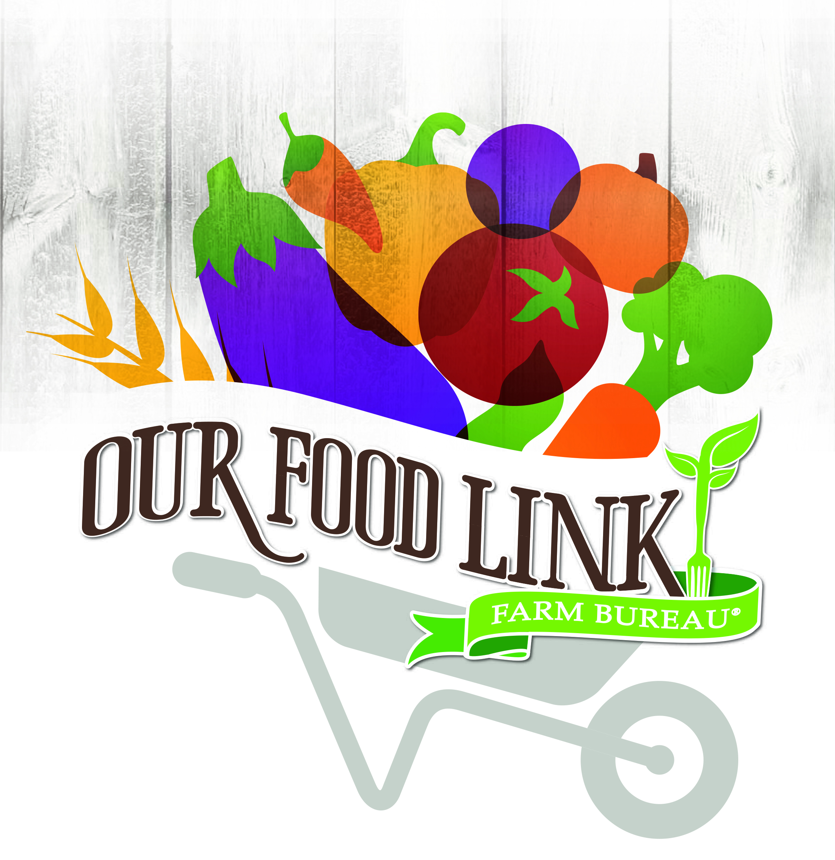
SAMPLE PROCLAMATION

[NAME OF GOVERNMENT AGENCY]
FOOD CHECK-OUT WEEK
February 19-23, 2018
By [TITLE OF OFFICIAL]
A PROCLAMATION
WHEREAS it is important that Americans have access to and consume healthful foods containing adequate vitamins, minerals, fiber and other nutrients; and
WHEREAS achieving better nutrition with fewer resources remains a shared concern of our citizens that can be addressed through consumer education and wise shopping strategies; and
WHEREAS Florida farmers and ranchers are unmatched in their ability to consistently produce an abundance of safe, nutritious and affordable food; and
WHEREAS producers confront significant uncertainties including inclement weather, damaging insects and other challenges, on a daily basis; and
WHEREAS [COUNTY OR STATE] farmers, ranchers and others involved in agriculture, working together in an environmentally sustainable way, help feed people here in [COUNTY/CITY], our state, our nation and in other countries around the world;
NOW, THEREFORE, I, [We] [NAME OF OFFICIAL(S)], [TITLE OF OFFICIAL(S)], do hereby proclaim February 13-17, 2017, as Food Check-Out Week. I [We] call upon all Americans to join me [us] in recognizing and reflecting upon the strength of our diverse agricultural production and in celebrating its achievements with appropriate observances and activities.
IN WITNESS WHEREOF, I have hereunto set my hand this (DAY) of (MONTH), 2018.

