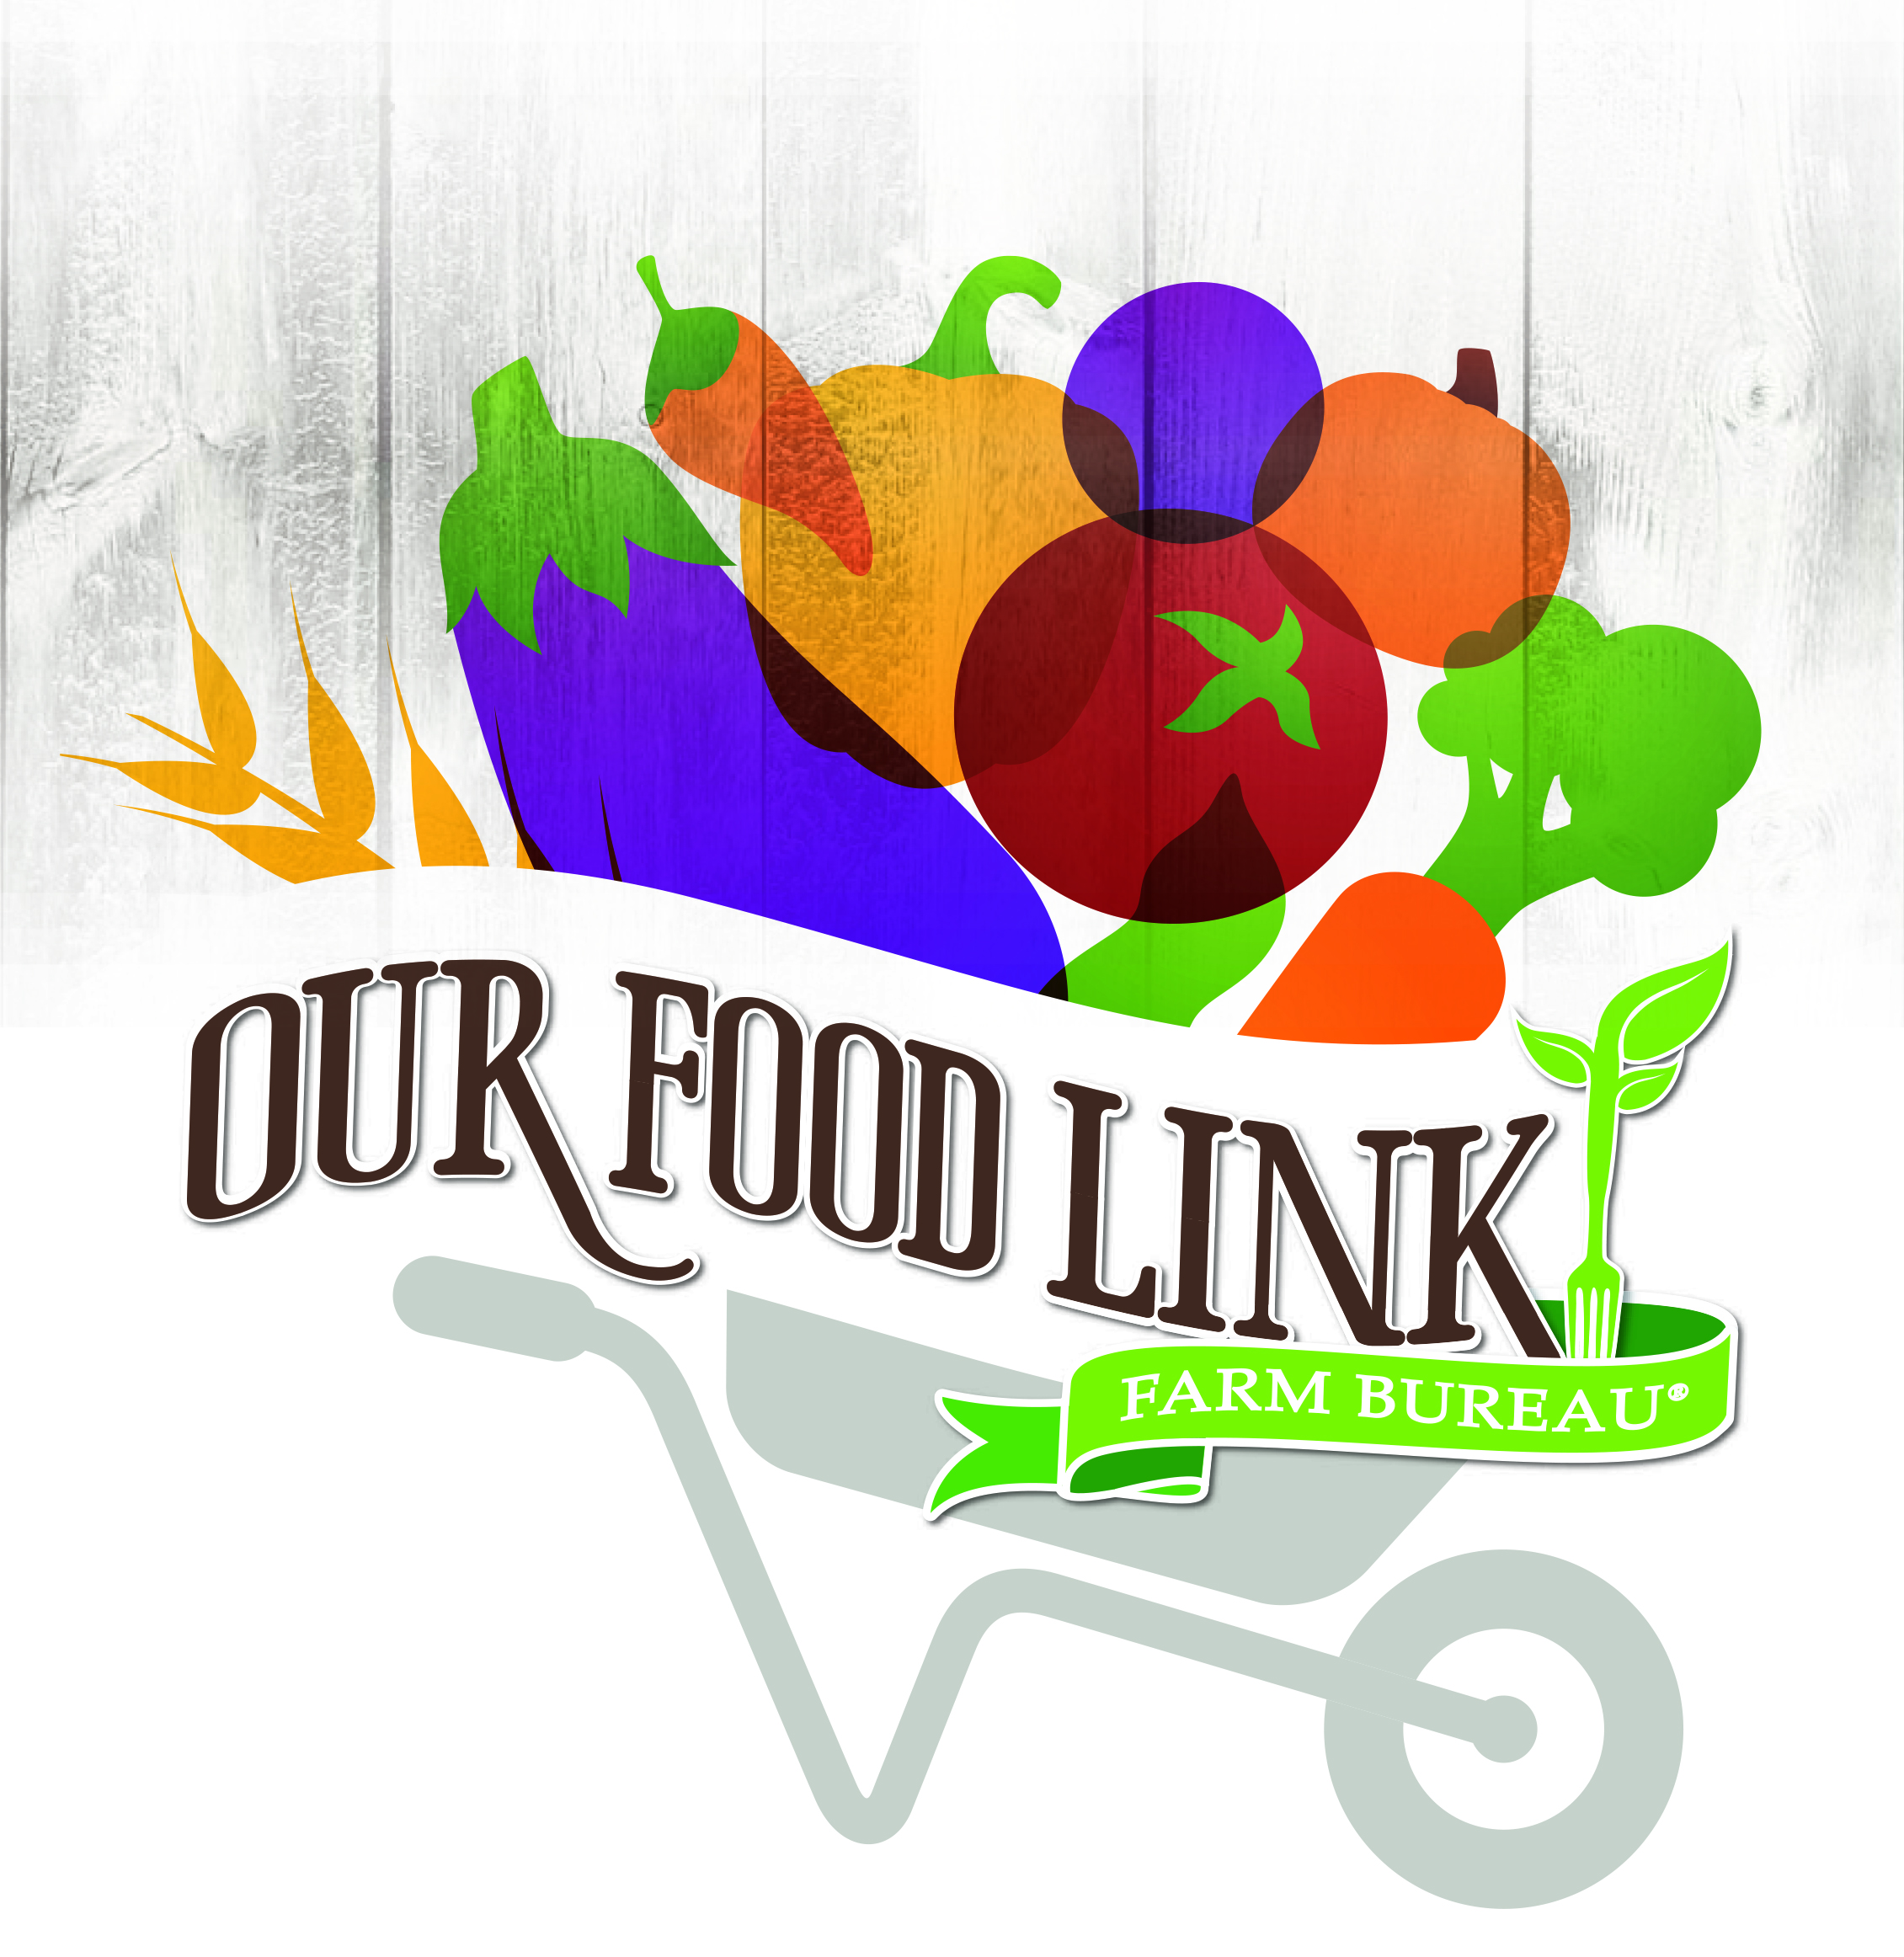
SAMPLE PRESS RELEASE

{County Logo]
[Date]
[Contact Name and Information]

Food Check-Out Week Event Highlights Farm Service to the Community

(Town) Members of the ___________________ County Farm Bureau will celebrate Food Check-Out Week on (date) by < INSERT ACTIVITY THAT COUNTY MEMBERS WERE INVOLVED IN>.

A fundamental part of our well-being as a society depends upon the domestic production of food. Our farmers and ranchers provide us with an abundant, nutritious food supply throughout the year. Food Check-Out Week, set for Feb. 19-23, commemorates the value of this achievement for all Floridians.

Local Farm Bureau members have volunteered to lead the event. They represent farm families throughout the area. We invite area residents to join us in this community activity.

County Farm Bureau President (or another volunteer leader) __________________ said, “INSERT QUOTE.”
(County) Farm Bureau is affiliated with the Florida Farm Bureau Federation, the state’s largest general interest agricultural organization, representing more than 145,000 member-families. Florida Farm Bureau serves to enhance farm enterprise and improve rural communities.
###

