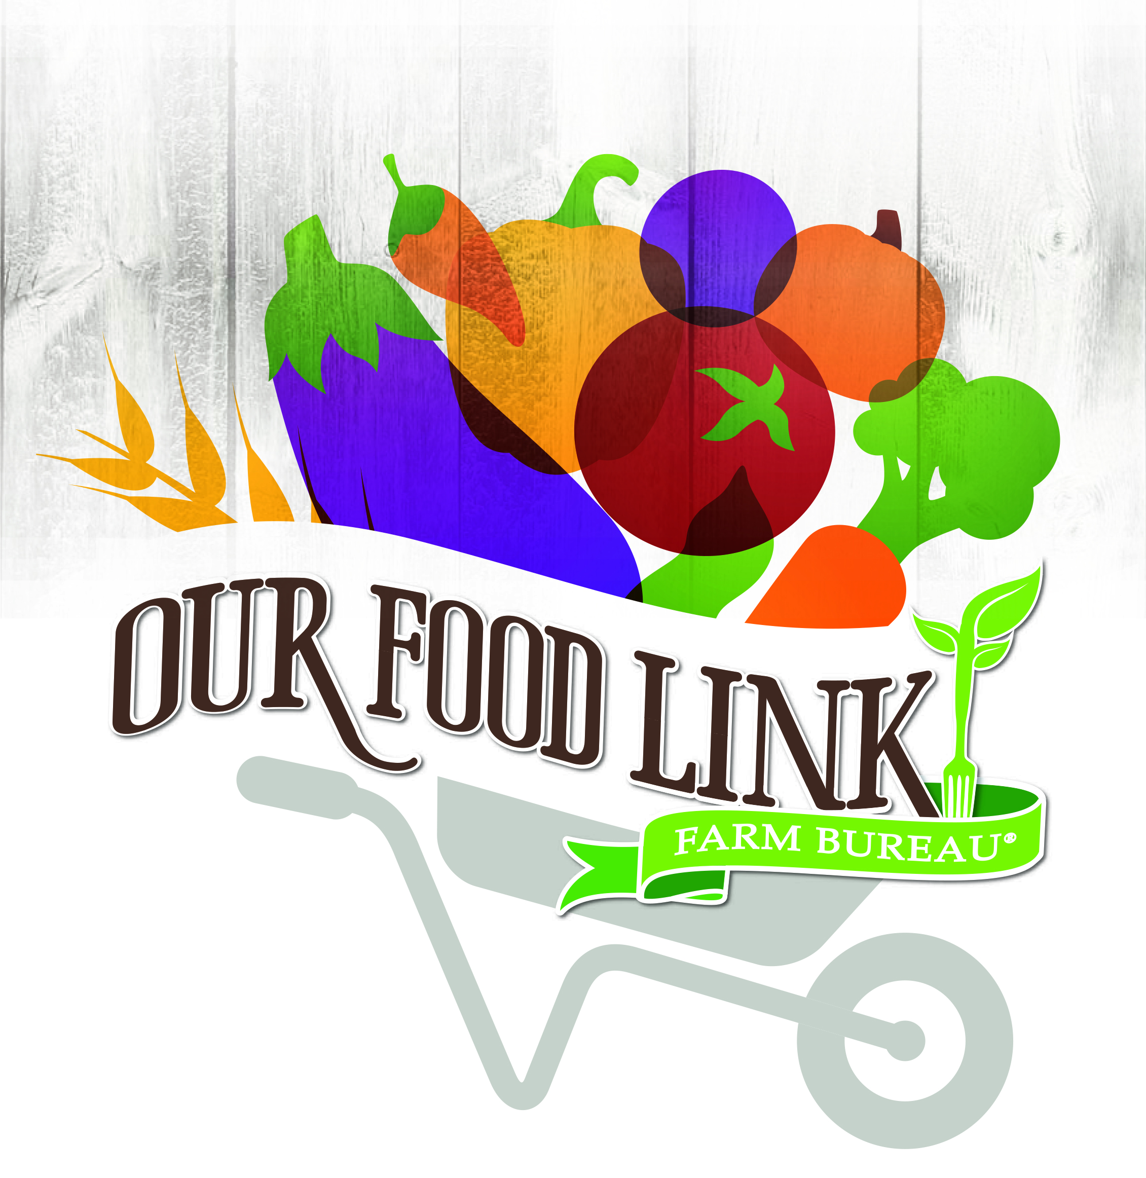
SAMPLE LETTER TO THE EDITOR

[Date]
[Contact Name and Information]

Dear Editor:

The foundation of our well-being as a society depends upon the domestic production of food. Our farmers and ranchers provide us with an abundant, nutritious food supply throughout the year.

In recognition of this achievement, members of the ___________County Farm Bureau and _________________ will celebrate Food Check-Out Week from Feb. 19 through Feb. 23. We will <STATE EVENT OR PROJECT.>

We are pleased to share this abundance with our fellow residents.

Thanks to the productivity and efficiency of Florida’s agricultural producers, they continue to maintain a stable bounty of food in our communities. Their dedication and skill level have overcome a difficult marketplace, weather extremes and plant and animal pests and diseases.

Their effective natural resource management provides crucial environmental benefits to all Floridians. According to state officials, farmers and ranchers conserve 12 billion gallons of water each year by their care.

Farm families achieve these successes despite receiving a steadily smaller portion of the retail grocery dollar. According to new U.S. Department of Agriculture data, in 1973 farmers and ranchers received approximately 30 cents out of every dollar spent on food. By 2016 the share farmers and ranchers received had declined to approximately 17 cents. The pattern remains the same for this year. Off-farm costs – processing, packaging, transportation, wholesaling and retailing – account for the majority of the food prices consumers pay.

Most of the recent increases in retail food prices have been the result of higher prices of energy needed to process, haul and refrigerate food.

Our bountiful domestic food supply is the product of skill and dedication. We invite area residents to join us in celebrating the farmers and ranchers who grow healthy and nutritious foods.

The ________________________________ County Farm Bureau urges you to join us in our Food Check-Out Week event(s). We are proud to highlight Florida agriculture and the people who make it successful.

(Signed)
###

