TALKING POINTS
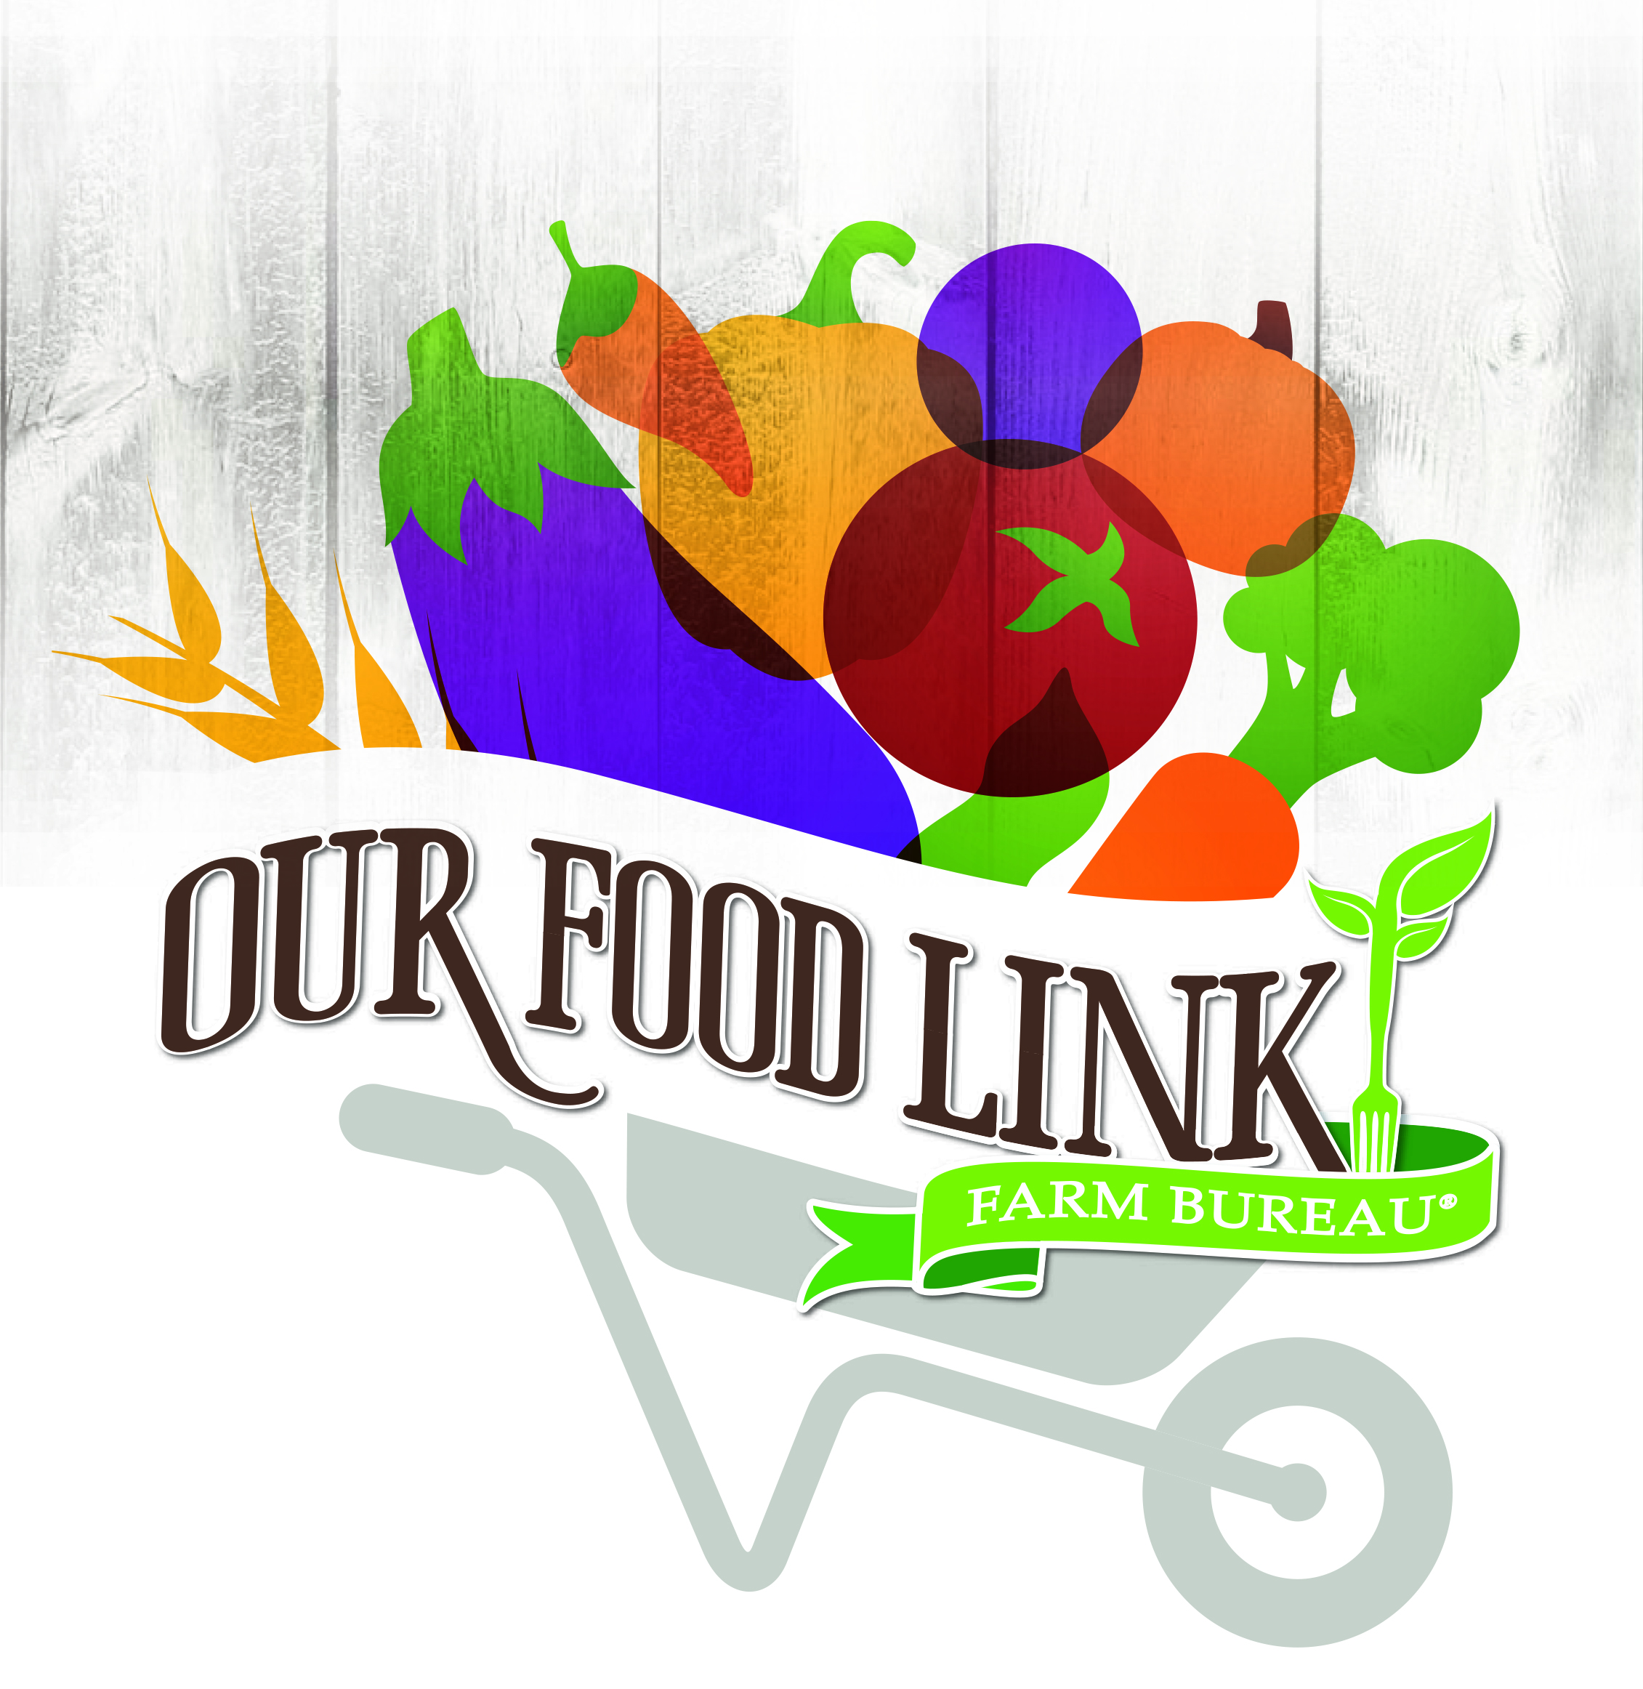
- The average American is three generations removed from the farm. Food Check-Out Week is a time to recognize the productivity of farmers and ranchers and help educate more people about where their food comes from.
- Designated the third week in February, Food Check-Out Week is traditionally the time that many families have earned enough income to buy their groceries for the year.
- When applied to calendar days, the average American earns enough income to pay for an annual supply of food in just seven weeks. By comparison, the same person must work until mid-April to pay for yearly income taxes. That’s seven weeks for food and more than three months for taxes.
- American consumers spend less than 10 percent of their disposable income (money for spending or saving) for food, compared to 18 percent in 1960. (U.S. Department of Agriculture’s Economic Research Service)
- Based upon the most recent studies, the U.S. Department of Agriculture reports that the “farmer’s share” of the food marketing bill at the grocery store or restaurant is 17.2 cents.
- According to the U.S. Department of Agriculture’s 2014 Consumer Expenditure Survey, 59 percent of domestic food purchases are groceries for home, while 41 percent is spent at a restaurant.
- Technological advances in agriculture have been influential in driving change in the farm sector. Farmers are able to grow more on less land. Total farm output more than doubled between 1948 to 2011.
- A health-boosting diet includes varieties of fruits, vegetables, low-fat or fat-free dairy products, lean meats, beans, eggs and nuts in quantities for daily calorie needs. According to the USDA, all forms of fruits and vegetables count towards a good diet – fresh, frozen, dried and canned.

- Plan balanced meals using the U.S. Department of Agriculture’s MyPlate food guidelines. Visit http://www.choosemyplate.gov/ for more information.
- The agency recommends that half of your plate should consist of fruits and vegetables; half of all grains should be whole grains. USDA researchers also suggest the use of fat-free or low-fat milk.

- Local farmers’ markets often have fresh vegetables, fruits, meats and other items that have been produced in the surrounding area near your home.
- Both crop and animal food production are guided by Best Management Practices – state-of-the-art techniques designed and tested by experts at research universities.
- Energy prices will continue to play a major role in retail prices for food and other items in the U.S. economy. The recent declines in fuel price will ease the upward pressure on most consumer items.
- Florida Farm Bureau’s Young Farmers and Ranchers have donated more than 16.9 million pounds of fresh produces and food to assist hungry Americans.
- The Florida Farm Bureau Women have distributed more than $200,000 to various charities through the Women’s Fund.

- Support local farmers and ranchers by purchasing the foods they produce.

