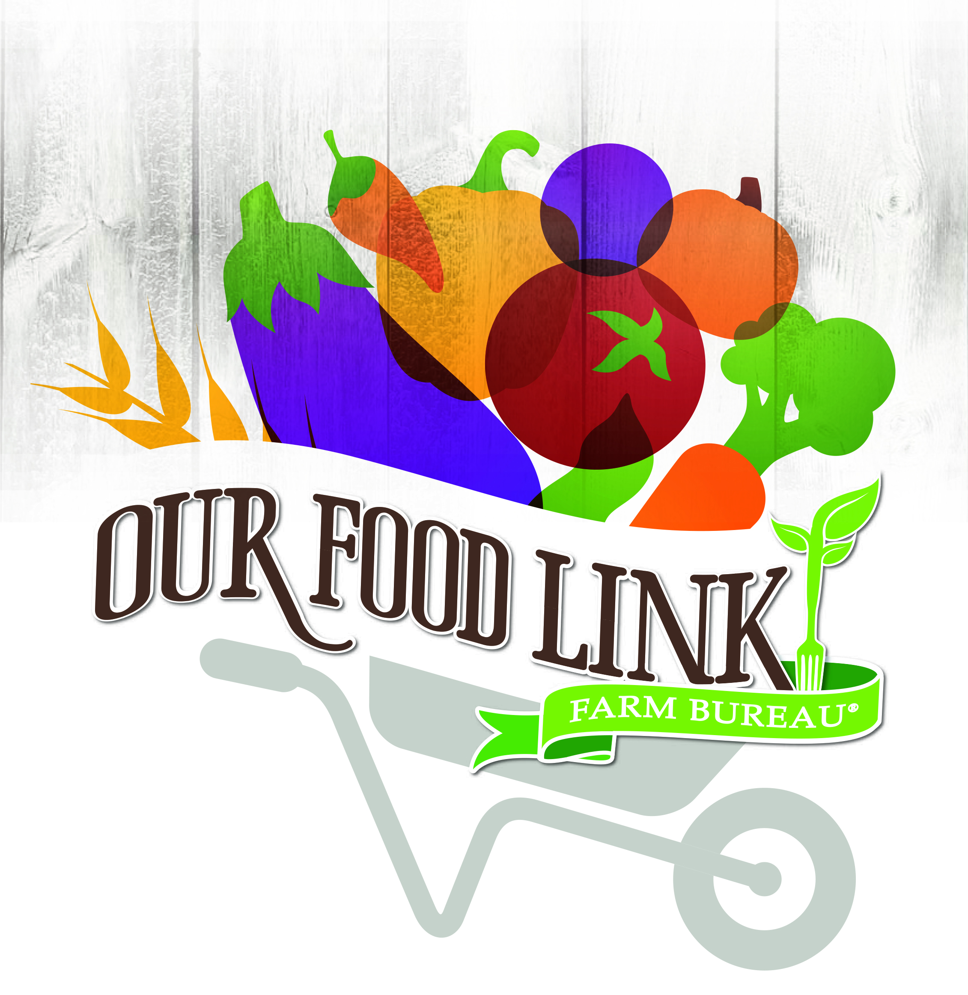
SAMPLE MEDIA ADVISORY

[County Logo]
[Date]
[Contact Name and Information]
MEDIA ADVISORY
Local Farmer Invites Public to Harvest Fresh Veggies for Food Bank

Introduction paragraph of event purpose can be one-two lines.

What: Name of event
Who: Farm name/subject name
When: Date of event and time
Where: Address of event location
Why: State the purpose of event in regards to Food Check-Out Week

For more information, contact <NAME at PHONE>
###

