2017 Florida Farm Bureau Federation Advisory Committee Nomination Form
County: Click here to enter text. | Committee Nominated for: Click here to enter text.
Name of Nominee: Click here to enter text. | Membership #: Click here to enter text.
Mailing Address: Click here to enter text. | Home Phone: Click here to enter text.
City: Click here to enter text. | Business Phone: Click here to enter text.
Zip: Click here to enter text. | Mobile Phone: Click here to enter text.
Email:
Is the nominee engaged in the production of the commodity for which he/she is nominated?
(N/A for Labor, Tax and Water/Natural Resources Committees) |  | Yes |  | No

Commodities produced: Click here to enter text.
Approximate size of operation (acres and/or head):  Click here to enter text. |  | Percent of income from commodity for which person is nominated: Click here to enter text.
Farm Bureau positions held (past or present):  State Board Member  County President  County Board Member  State Advisory Committee Member  AFBF Advisory Committee Member  YF&R State Committee/Leadership Program |  | Number of years producing commodity:  Click here to enter text.
Other commodity group affiliation:
Click here to enter text.
Instructions:
- Refer to State Advisory Committee Guidelines
- County Farm Bureau Boards or nominating committees should thoroughly consider nominations and submit qualified nominees
- Nominees should be notified of their nomination BEFORE the form is submitted
- Please fill out the form COMPLETELY
- Fax or email nomination forms to:
Ag Policy—352.374.1592
Maureen.Harkey-Torres@ffbf.org
Deadline for nominations is August 26, 2016.
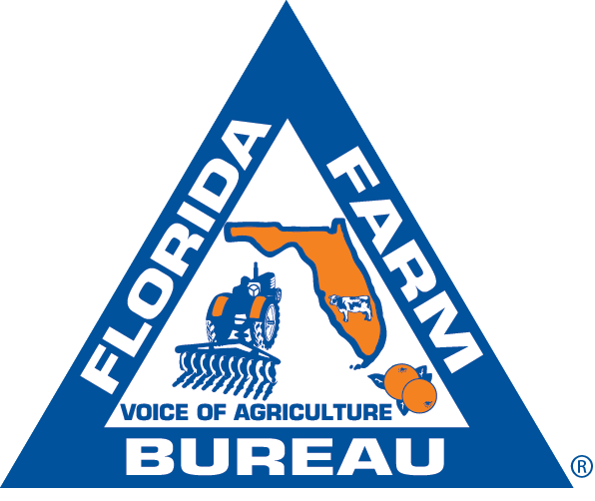

I have read and understand FFBF’s State Advisory Committee Guidelines.
I have notified the member of his/her nomination.

____________________________________________ Date: (Click here to enter a date)
(County Farm Bureau President)

